Nitrogen Pressure Sensor

Description

This module checks that the nitrogen pressure into the bag is above a set value. This will then warn the user is the pressure is too low.

Usage

Use the machine as normal, when the gas pressure is too low then the buzzer will sound and the red button will flash. After 2 mins the buzzer will silence (if DIP4 is set to OFF) and the red button will continue to flash until the error is corrected.

The buzzer can be silenced immediately if the red button is pressed.

Controls

* Green OK LED illuminates if the pressure is above the set level.
* Red LOW LED illuminates if the pressure is too low.
* GAS PULSE button simulates the machine requesting a gas pulse.
* BUTTON is used during calibration.
* RESET is used to reset the module.

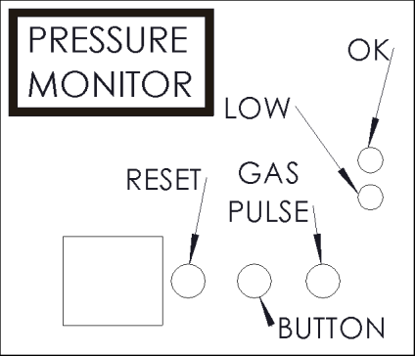

DIP Switches

Switch 1 & 2 sets the tolerance level before a low level alarm is triggered.

Switch 3 is used to calibrate the pressure sensor.

Switch 4 is used to auto silence the timer after 2 mins.

|  |  |  |  |  |
| --- | --- | --- | --- | --- |
| Switch | Function | On | Off | Default |
| 1 | See tolerance table | | |  |
| 2 |  |
| 3 | Calibrate sensor | Calibrate | Run | OFF |
| 4 | Auto silence | No silence | Auto silence | OFF |

Tolerance table

|  |  |  |
| --- | --- | --- |
| Switch 1 | Switch 2 | Tolerance |
| OFF | OFF | 0% |
| OFF | ON | 10% |
| ON | OFF | 20% |
| ON | ON | 30% |

Calibration

1. Set required pressure on the gas bottle regulator.
2. Set DIP switch 3 to OFF.
3. Press either button on module or silence button on front of machine.
4. Set DIP switch 3 to ON.
5. Adjust tolerance settings using DIP 1 & 2.

All circuit diagrams and source code can be found at https://github.com/RDickens/Packing-machine